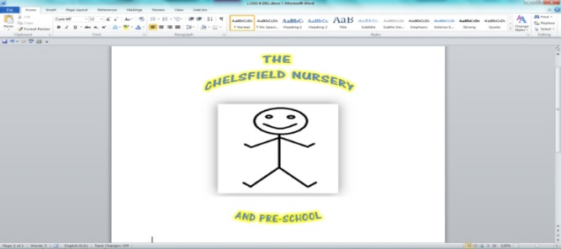



Web site: thechelsfieldpre-school.com

Email: chelsfieldbrom@yahoo.co.uk

**Ofsted rated good March 2023**

**Child protection policy**

The Chelsfield Nursery and Pre-school

Acknowledges the duty of care to safeguard and promote the welfare of children and young people and is committed to ensuring safeguarding practice reflects statutory responsibilities, government guidance and complies with best practice.

**This policy:**

1. applies to all adults including the Directors, volunteers, paid staff, agency staff and anyone working on behalf of The Chelsfield Nursery and Pre-school.

b) recognises that the welfare and interests of children and young people are paramount in all circumstances; and

c) aims to ensure that all children and young people have a positive and enjoyable experience of education in a safe and child centred environment and are protected from abuse whilst participating in said education.

The Chelsfield Nursery acknowledges that some children and young people, including those disabled and those from ethnic minority communities, can be particularly vulnerable to abuse and accepts the responsibility to take reasonable and appropriate steps to ensure their welfare.

The Chelsfield Nursery and Pre-school

1. promote and prioritise the safety and wellbeing of children and young people.

2. ensure that everyone is clear about their roles and responsibilities in respect of safeguarding and is provided with appropriate learning opportunities to recognise, identify, and respond to signs of abuse, neglect and other safeguarding concerns relating to children and young people.

3. provide all the parents of the children joining the Setting, the nursery’s safeguarding arrangements;

4. widely promote the nursery’s safeguarding policies and procedures.

5. ensure that staff and volunteers take seriously all concerns and allegations of abuse and respond appropriately.

|  |  |  |
| --- | --- | --- |
| This policy was adopted by | The Chelsfield Nursery |  |
| On | September 2024 |  |
| Date to be reviewed | September 2025 |  |
| Signed on behalf of the provider |  | |
| Name of signatory | Gary Carter | |
| Role of signatory | Director | |