Contents Page

**Page 3**: Welcome and Contact details.

**Page 3-7**: The team

**Page 8**: Key Person

**Page 9**: Learning Journals: Your Child’s First day and home time procedure.

**Page 10**: What to bring with you, Clothing and Collection policy.

**Page 11**: Lateness and Accidents, Sickness and

Medication

**Page 12-15**: Food and Drink and Our Safeguarding

policy

**Page 16**: Pre-school and Nursery registration form

**Page 17**: Health declaration and consent form

**Page 18**: Settling in form

**Page 19-20**: Bromley Early Years Parent Funding

Contract

Welcome!

I would like to start by welcoming you to The Chelsfield Pre-school and Nursery and hope your association with the school will be a long and enjoyable one.

At the Chelsfield Pre-School and Nursery the children are at the heart of all we do. We aim to ensure each child’s happiness by creating a secure, caring and stimulating environment. Having an enabling in environment helps each child to develop their own attitudes, beliefs, and abilities. From start to finish we share a team commitment to achieve the best for each induvial child no matter what their needs may be.

The Chelsfield Nursery and Pre-school has been established for ten years as a Pre-School and over 6 years as a Nursery. The Nursery is based in a large community hall with a large outside environment which includes a natural woodland area at the back of the garden. The ethos of the Nursery is a Free-Flow play environment, this means the children are leaders in their own learning, exploring the weekly pre-planned activities at their choice. The garden in open and available to the children in all weathers.

Within the Nursery we strongly believe that a key factor in helping children develop and achieve is having a strong bond between school and home. We always welcome parents to make appointments with their Key Person and work together to support your child. The purpose of this pack is to provide you with information about the Nursery, procedures we follow which you need to be familiar with.

Telephone number – 01689 853183

Email – [chelsfieldbrom@yahoo.co.uk](mailto:chelsfieldbrom@yahoo.co.uk)

Website – [www.thechelsfieldpre-school.com](http://www.thechelsfieldpre-school.com/)

**Our staff:**

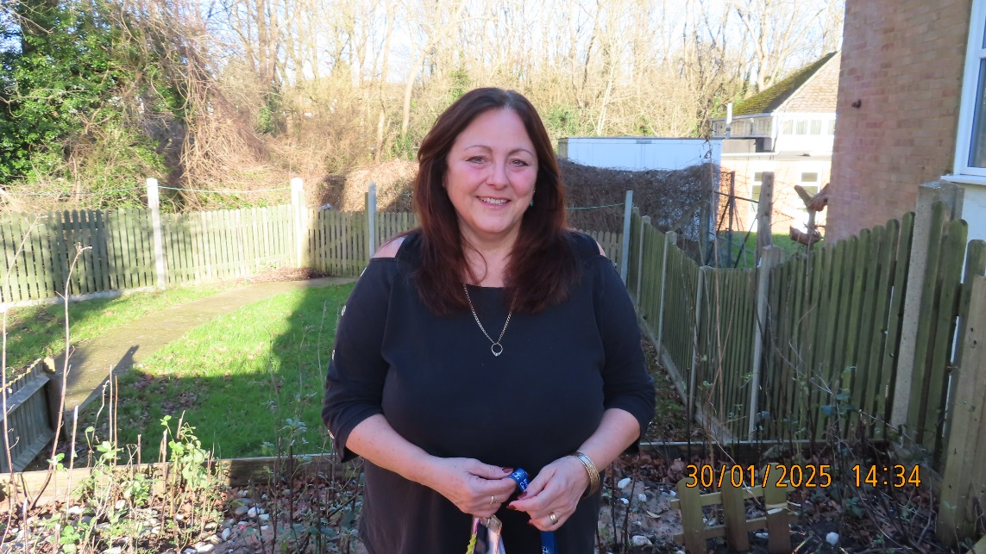**All our staff have up to date DBS certificates and have regular training. Each staff member issued with a lanyard which retains information about their qualification, name and DBS number. All our team are Paediatric first aid level 2 trained.**

**Julie Carter**

**Owner/Director**

**“Hi! My name is Julie Carter” and I have worked in childcare for over 40 years, completing my NNEB, NVQ3 and various SEN training. I have worked my way up from level 3 to SENCO leader, deputy manager to manager and now enjoy being the owner to my setting of a fantastic team of people. My vocation always has been to be provide children with a fun and safe learning environment.”**

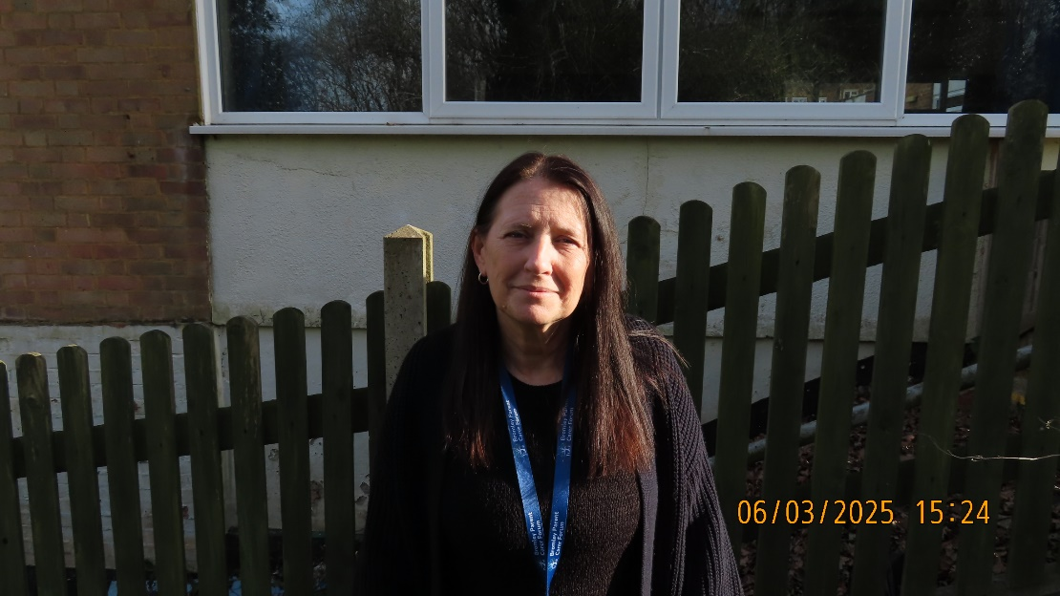

**Denise Danaher**

**Manager, Safeguarding Lead and Level 3 qualified.**

**“My name is Denise” I have worked at Chelsfield Pre-school for 10 years. I initially started by doing voluntary work a few hours a week. I moved on to complete my level 3 Diploma for children and young people. I am now a Key Person, Manager and one of the Safeguarding Leads. I have completed many courses such as paediatric, safeguarding, food hygiene and autism awareness to keep our children safe**



**Gary Carter**

**Admin Director and Caretaker**

**“My name is Gary” and after working 38 years as a trade’s person, I have joined the team at the Nursery. I take on the caretaker role, painting, garden maintenance and building work. I also keep the IT equipment running.**

**Oh, and also, I’m Julie’s Husband!”**

**Wendy Teall**

**Level 3 Practitioner – Deputy Manager – Setting SENCO**

**I have worked in childcare for over 40 years in different roles and settings. I have worked at the Chelsfield Nursery for the past 7 years. I am continuously updating my knowledge and practises through courses, forums, advise from outside professionals and from personal experience of being a mother and grandmother.**

**Laura Hooper**

**Level 3 Practitioner**

**I have been in childcare for 26 years and have worked my way up from an apprentice to a manager, I have worked with all ages ranging from 3 months – 12years, I’d rather stick with 2-4years now. I did however take a break from working in a nursery and I was a nanny for 8 years for 3 families. I did miss working in a nursery setting due to missing the interaction with adults/children. I love working with all children “they do make me laugh “ with what they say! And they bring so much joy and happiness to my day.**

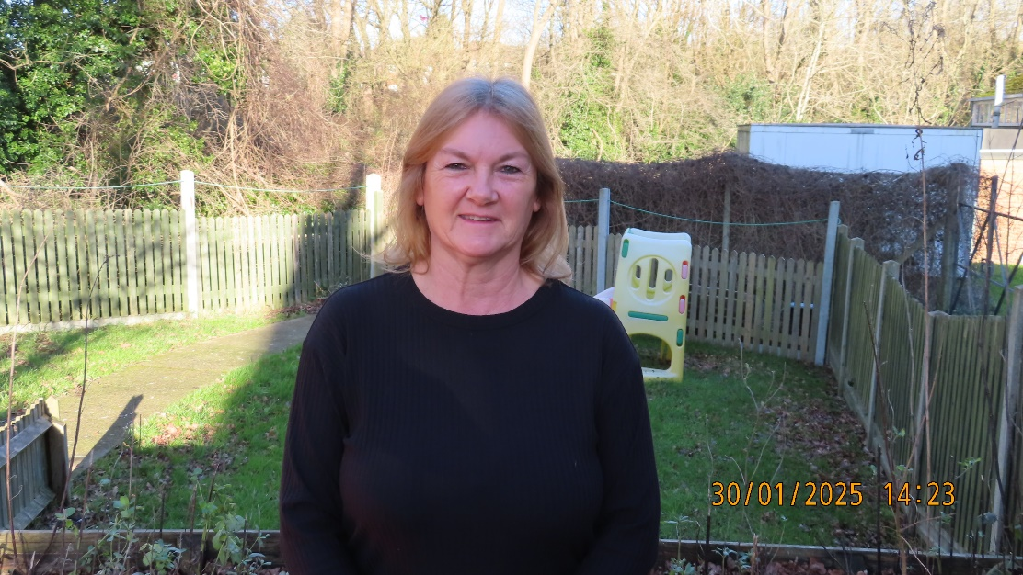

**Carol Barnard**

**Level 2 practitioner**

**Hi, my name is Carol. I have worked in childcare for 15 years teaching all ages from 6 months to 5 years. I have a level 2 in childcare and a level 2 in team leadership qualifications. My passion is teaching and helping the children to reach their milestones and achieve the goals they set out to do. In my spare time I like to be with my family and friends.**

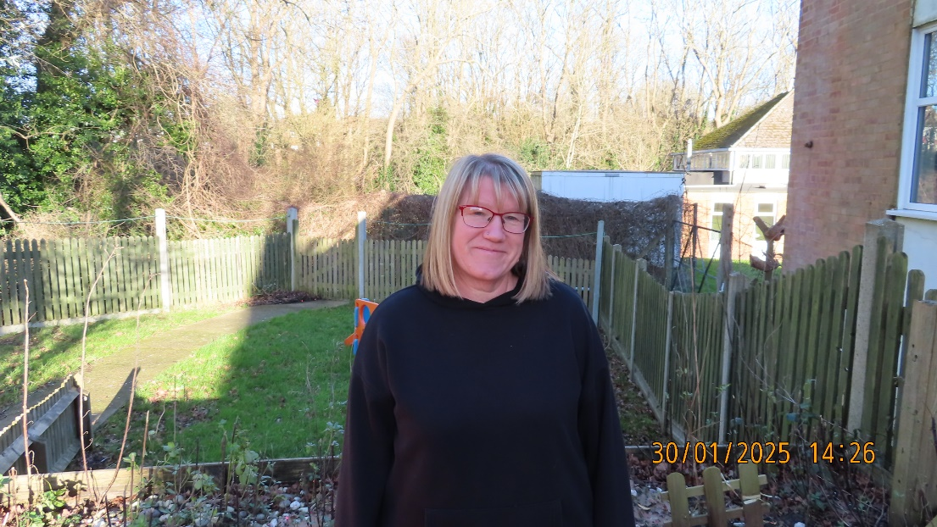

**Claire Barrow**

**Level 2 practitioner**

**My name is Claire. I started out my career in childcare volunteering as a SIPS worker, working 1-1 with a small boy, it was quite challenging but I enjoyed it so I went on to do my Level 2 in childcare. I have been working with children on and off for 10 years. I enjoy spending time with family and friends in my spare time and I like going to concerts and the theatre.**

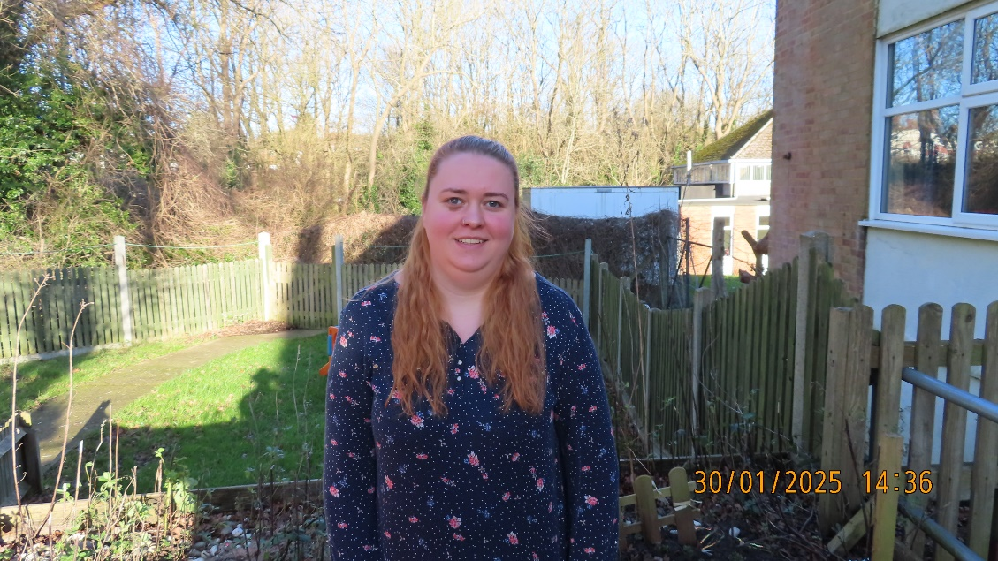

**Kimmie Dale Chef**.

**I love working in this kitchen preparing a variety of healthy meals and designing the menus. I also order the food and ensure that the kitchen is kept in a clean and healthy condition, we have been consistently awarded a level 5 food and hygiene award from Bromley.**

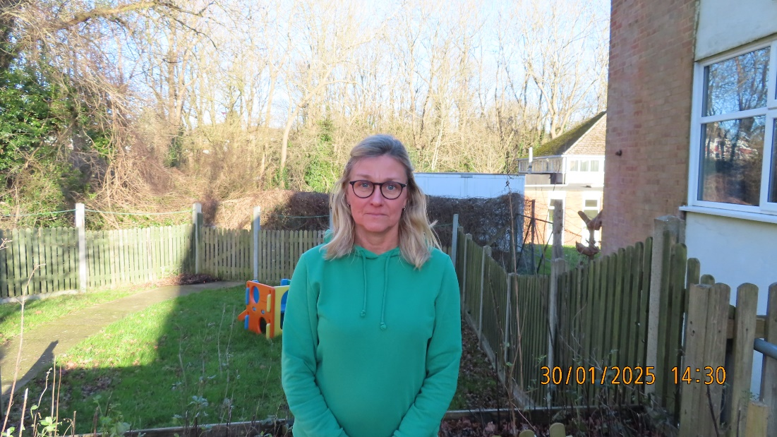

Dance Teacher and Bookkeeper

“Hi, my name is Zena” I come into the nursery once a week to teach dance on different days so all the children can participate, I also enjoy choreographing the Christmas nativity dance.

My other role in the company is that of bookkeeper which I carryout of site at the office, I continue to teach both Ballet and street dance at various venues.



The Key Person Approach

Children thrive from a base of a loving and secure relationships. This is the aim of the Key Person to build this strong caring environment whereby each child feels safe and cared for. A key person is a named member of staff with responsibilities for a small group of children, who they observe and recorded their developing milestones in a learning journey (profiles). The Key Person nurture’s all areas of a child’s development, helping and supporting milestones such as toileting and dressing.

Your child’s key person will be a familiar figure who is accessible and available for the child and yourselves. It is paramount for us to work in partnership to provide all around care for you child, so please do not hesitate in raising any worries you may have as we are here to work together and help. It is important that if you child has any specific learning requirements you inform your Key Person and Julie. This can include allergies as we have an allergy board highlighting any specific needs for your child.

The Key person will be assigned to your child before or on their first day to offer that supporting relationship to build from the start. However, on occasion this can change due to your child naturally bonding with another Key Person or if a staff member leaves. On both occasions the new Key Person will be assigned because they are the closest member of the team to your child. If any changes are made you will be spoken to, or if you have any queries, you can raise this with any member of the team.



Learning Journeys (Profiles)

At the Chelsfield Pre-School and Nursery we use **learning journeys** as visual evidence that each child is achieving developmental stages in relation to the Early Years Foundation Stage (EYFS, 2024). The profiles will be made from written observations observed in the setting by all members of the team and photos of the child’s achievements. Each profile is done over two months, analysed using the EYFS (2024) providing Next Steps to support your child’s on going journey of development.



Your child’s first day

Welcoming your child to our Pre-School/Nursery is a privilege as it will be a milestone in their education and learning. Every child is different when joining a new setting, we understand this time can be worrying and exciting all in one. To help ease this transition we offer the opportunity for you and your child to meet the team and get familiar with the setting.

On the day of your child joining, your welcome to join us for a couple of morning session to help settle your child, showing them where their peg is, where the nappy/toilet room is and modelling to them this is a safe environment. If the child can see you playing and joining in activities on that day it should help to show them this is an environment where it’s safe, that they can play and enjoy themselves. After this time though it is best for you to leave your child to allow them to develop their own relationships with the team without you.



Home time procedure

In the mornings when dropping off your child you are welcome to come in, hang up coats/bags and say goodbye to your child, however this is different from our home time procedure. For Pre-Schoolers collecting at 12:15pm, we will get your children ready for home time and bring your children to the door, you will not be able to enter the building unless you need to speak to a member of staff. This is to maintain the routine for the Nursery children staying.



What to bring with you

We encourage you to bring a bag and coat with you each day for your child. In their bag, please provide the relevant for your child: Nappies, Wet wipes, several spare pairs of pants/kickers, several leggings/trousers and socks. This is particularly important when your child starts potty training. Also, we ask you bring in a named water bottle to keep at the setting.



Clothing

We do not have a Uniform, but we do ask children do not come into school with laced up shoes, no dresses, skirts, or skinny jeans as this can limit their ability to play and/or can be time consuming for staff changing your child.



Collection Information/ Holiday’s during term time

When joining the setting it is encouraged to share photos of people who will be collecting your child, for example grandparents, childminders, this is about our safeguarding commitment to you child. Furthermore, if on occasion you have arranged a different person to collect your child, we encourage the use of a password. This is chosen by the parent/carer and shared with us and the person collecting, as well as the name of the person collecting.

If you chose to take your child on holiday during term time, you will still need to make your normal payments. Before going on holiday please inform the Nursery/Pre-school as this will need to be recorded in our attendance book, otherwise you will receive phone calls asking why your child is not present at Nursery/Pre-School.



Late

If you are running late, please contact us (01689 853183) as it can become very distressing for the child not knowing where you are. As a part of our policies if you are running late there will be a fee as it means staff have to stay later. You can also arrange over the phone, a change of collection. Please confirm a chosen password and the name of the person who will be collecting. The password would be for the Nursery and the person collecting to identify they are the correct person.



Accidents, Sickness and Medication

There is always a member of staff with relevant First Aid/Paediatric Qualification on site and an up to date first aid box on premises. If an accident or incident occurs, we record this on a sheet which logs the date, time, staff member who observed it and the details, this is then shared with you the parent/carer and then signed and stored in a secure cupboard.

If your child is ill during the day at Pre-School/Nursery we will contact you or your emergency numbers provided on the registration form, to come and collect them to prevent others from catching any illness. We ask that if your child has been ill with Sickness or Diarrhoea that you do not bring them into the setting for 48hours after the Sickness/Diarrhoea has stopped this is to prevent the spread of infection.

If your child becomes ill, please can you contact us as we record all sicknesses in a log, if you forget a phone call will be made by us asking why your child isn’t attending, recording the conversation in the attendance book. This also applies if your child has any medical problems, we need to be made aware of.



Safeguarding Policy

Our setting will work with children, parents and the community to ensure the rights and safety of, children, young people, and vulnerable adults. Our Safeguarding Policy is based on the three key commitments of the Learning Alliance’s Safeguarding Children Policy.

***Key commitment 1***

We are committed to building a 'culture of safety' in which children, young people and vulnerable adults are protected from abuse and harm in all areas of our service delivery.

***Key commitment 2***

We are committed to responding promptly and appropriately to all incidents, allegations or concerns of abuse that may occur and to work with statutory agencies in accordance with the procedures that are set down in **'What to do if you’re worried a child is being abused**.’

***Key commitment 3***

We are committed to promoting awareness of child abuse issues throughout our training and learning programmes for adults. We are also committed to empowering children through our early childhood curriculum, promoting their right to be strong, resilient and listened to.

Our safeguarding leads are:

Julie Carter - Designated Lead

Denise Danaher - Deputy Designated Lead