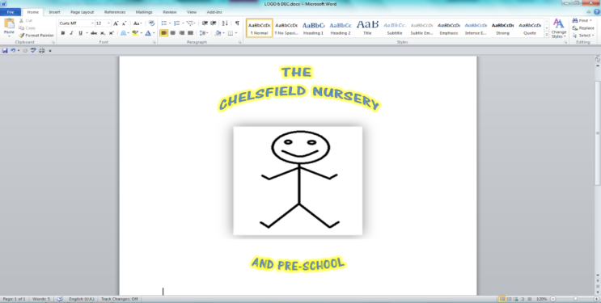



Web site: thechelsfieldpre-school.com

Email: [chelsfieldbrom@yahoo.co.uk](mailto:chelsfieldbrom@yahoo.co.uk)

01689853183

**Rated Good March 2023**

**Terms and Conditions**

The document and the terms and conditions within it govern the basis on which the Chelsfield nursery ltd (referred to here as we agree to provide childcare services to parent(s)/guardian(s) (referred to as ‘you’).

Only a parent/guardian with parental responsibility for a child can register that child for a childcare place with us. We will ask to see your child’s birth certificate, or other relevant documentation, to confirm that you have parental responsibility for the child as part of our registration process.

|  |  |  |  |  |
| --- | --- | --- | --- | --- |
| **Commencement date of agreement:** | |  | **Expiry date of agreement**: |  |
| **Review date:** |  | | | |

Ofsted URN: EY449675 Insured by: Royal sun alliance Insurance plc

Insurance policy number: RTT209837

|  |  |  |  |  |  |  |  |  |  |  |  |  |  |  |  |  |  |  |  |  |  |
| --- | --- | --- | --- | --- | --- | --- | --- | --- | --- | --- | --- | --- | --- | --- | --- | --- | --- | --- | --- | --- | --- |
| **Your details:** | | | | | | | | | | | | | | | | | | | | | |
| Full name of parent/guardian (1) | | | | | | |  | | | | | | | | | | | | | | |
| Address |  | | | | | | | | | | | | | | | | | | | | |
|  | | | | | | | | | | | | | | | | | | | | | |
| Telephone | |  | | | | | | | | | Email | |  | | | | | | | | |
| Full name of parent/guardian (2) | | | | | | |  | | | | | | | | | | | | | | |
| Address |  | | | | | | | | | | | | | | | | | | | | |
|  | | | | | | | | | | | | | | | | | | | | | |
| Telephone | |  | | | | | | | | | Email | |  | | | | | | | | |
|  | | | | | | | | | | | | | | | | | | | | | |
| Full name of child | | | |  | | | | | | | | | | | | | Date of birth | | |  | |
|  | | | | | | | | | | | | | | | | | | | | | |
| **offer for a childcare place for your child:** | | | | | | | | | | | | | | | | | | | | | |
| Expected start date of child’s place | | | | | | | | |  | | | | | | | | | | | | |
| Settling in period | | |  | | | | | | | | | | | | | | | | | | |
| Agreed hours: | | | | | | | | | | | | | | | | | | | | | |
|  | | | | | | Monday | | | | Tuesday | | | | | Wednesday | | | Thursday | | | Friday |
| Agreed times of attendance | | | | | |  | | | |  | | | | |  | | |  | | |  |
| Total daily hours | | | | | |  | | | |  | | | | |  | | |  | | |  |
| Offered over [number of weeks] weeks per year. | | | | | | | | | | | | | | | | | | | | | |
| OR | | | | | | | | | | | | | | | | | | | | | |
| We will offer your child a place consisting of between 6 HOURS and 50 HOURS per week., You will need to provide us with your weekly schedule at least 28 days in advance. | | | | | | | | | | | | | | | | | | | | | |
| [Term/holiday] dates: | | | | |  | | | | | | | | | | | | | | | | |
| We are closed on bank holidays. Fees still apply. | | | | | | | | | | | | | | | | | | | | | |
| Deposit received | | | | Yes □ | | | | No □ | | | | | | First payment due | | | | | date | | |
| Will the child receive nursery education funding | | | | | | | | | | | | Yes □ | | | | No □ | | | | | |
| Details of any other funding provided by other third parties (e.g. employers childcare vouchers) | | | | | | | | | | | | | | | | | | | | | |
|  | | | | | | | | | | | | | | | | | | | | | |
|  | | | | | | | | | | | | | | | | | | | | | |
|  | | | | | | | | | | | | | | | | | | | | | |
|  | | | | | | | | | | | | | | | | | | | | | |

**Terms and conditions**

**Our obligation to you**

* 1. We will inform you as soon as possible whether your application for a place has been successful. You must confirm within one week of receiving notification that you still wish to take up a place. If you do not then the offer of a place may be withdrawn. Once you have confirmed the place, a holding payment will be required to hold the place for your child. The monetary value of this fee will be published as part of our schedule of fees which can be obtained on request.
  2. We will provide the agreed childcare facilities for your child at the agreed times (subject to any days when we are closed). If we change the opening hours, we will give you as much notice of our decision as possible and, if necessary, will work with you to agree a change to your child’s hours of attendance.
  3. Please refer to our parental contract and Early years prospectus for further information.